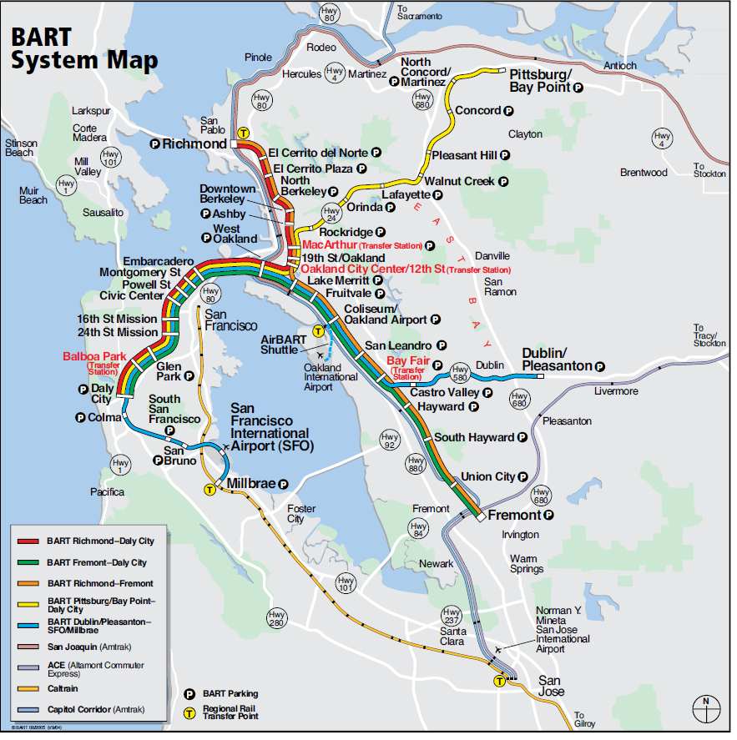
How would you take the BART from San Francisco Airport to Powell Street Station?

How would you take the BART from Oakland Airport to Embarcadero Station?

Weekdays (Mon-Fri) 4 am - Midnight
Saturdays 6 am - Midnight
Sundays and holidays 8 am – Midnight

“Tickets to Go” https://secure.transitstore.com/bart/step1.asp
buy red tickets %62.5 discount $24 tickets for $9 for the girls (get refunds for unused parts of the tickets) Oakland Airport ($13.10) or SF ($10.70) Round Trip ticket for adults. Available online.

